Semester Project

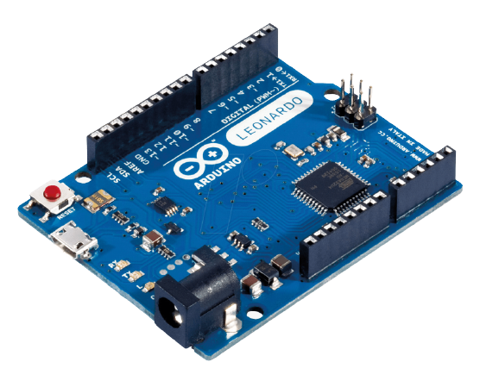

**Submitted By:**

Muhammad Sikander Shahbaz

CPEN-19111030

Autonomous Robot

Arduino UNO Based

**Project Detail**

|  |  |  |  |  |
| --- | --- | --- | --- | --- |
| **Semester Project** | | **Type (Autonomous Robot)** | | |
| **Project Group Members** | | | | |
| **Sr.#** | **Reg #** | **Name** | **Email** | **Signature** |
| (i) | CPEN-19111030 | Muhammad Sikander Shahbaz | muhsikandershahbaz@hotmail.com |  |

### CERTIFICATION

**Approved by:**

1. Project Supervisor

(Signature) (Name) (Date)

1. Head/In-Charge of the Department

(Signature) (Name) (Date)

Table of Contents

ABSTRACT ....................................................................................................................... i

ACKNOWLEDGEMENT .................................................................................................. ii

**CHAPTER 1 ...................................................................................................................... 1**

1.Introduction ..................................................................................................................... 1

1.1. Background ................................................................................................................ 1

1.2. Problem Description ................................................................................................... 1

1.3. Objectives ................................................................................................................... 1

1.4. Summary ..................................................................................................................... 2

**CHAPTER 2 ..................................................................................................................... 3**

2.Introduction to Sensors and Devices................................................................................ 3

2.1. Arduino ........................................................................................................................ 3

2.2. Ultrasonic Sensor ........................................................................................................ 3

2.3. Motor Driver ............................................................................................................... 5

2.4. LDR ............................................................................................................................. 5

2.5. Humidity and Temperature Sensor .............................................................................. 6

2.6. Autonomous Robot ...................................................................................................... 6

2.7. Circuits ........................................................................................................................ 6

**CHAPTER 3 ...................................................................................................................... 10**

3.1. Arduino Code ............................................................................................................... 10

3.2. Working of Robot ........................................................................................................ 14

**CHAPTER 4 ...................................................................................................................... 16**

4.1. Conclusion ................................................................................................................... 16

4.2. Future Work ................................................................................................................. 16

**Abstract:**

This project based on Arduino UNO. It’s an Autonomous Robot consist of different sensors to perform different actions. The car wheels driven by a motor driver which drives DC motors. The main highlight of this robot that it avoid obstacles in its way and changes its path according to the distance from the obstacle. Furthermore it turns on the headlights whenever it enters a dark atmosphere or where the light is dim it turns on the lights. It has a thermo sensor which detects the temp of the whole system implement on this board and also the atmospheric temperature. If the temperature is more than the defined limit (25°C) then it turns on the fan ported on it until temperature turns below the defined limit (25°C).

**Acknowledgement:**

First of all, very thanks to **“Allah Almighty”** who is our Lord and who is our all in all who never let the efforts go wasted? He made us to do this tedious work. We are nothing but Our Allah always blessed us a lot. Secondly, I would like to thanks to my institute KFUEIT. Development and Documentation phase is a great chance to learning and professional development for me and my team. I am grateful to **Engr. Nasir Hussain** (Lecturer) Computer Engineering Department Supervisor of my project and **Miss Amna Asif** (Lab Assistant) Computer Engineering Department Co-Supervisor of my project, for support, guideline and great supervision. Also, very grateful to **Dr. Ahmed Sohaib** (Head of Computer Engineering Department) for their support and appreciation. I again thank my course fellows for their good cooperation during the course. Throughout this phase of documentation, I did not only gain a lot of knowledge but more importantly, I also had a great chance to sharpen my skills in a professional working environment.

**Chapter 1**

1. **Introduction:**

**1.1 Background:**

As technology becomes increasingly important in today's world, it is invaluable to not only learn how to use technology, but also to understand how to create it. Since being the engineer one should have sound knowledge of the other discipline.Most of the projects have limted scope to only specific discipline.This would limit ones innovation and creativity. This project inspires to make connections across several disciplines rather than learning topics in isolation as it combines mechanical, electronic, electrical and programming skills.

* It gives visual grasp of math and science.
* It builds logical thinking.
* It brings out innovation and creativity.
* It enhances problem solving skills.
  1. **Problem Description:**

In real world we saw daily accidents in industrial garages or on roads or in bazaar due to laziness of the driver or un intentionally hitting others with their vehicle. This project can help them to detect whether there is an obstacle in some distance slow down the vehicle or apply brakes automatically. Also it operates in dark environment turns on lights and make its way to destiny. It also senses temperature to sense and avoid any unnecessary burning in vehicle. It is very usefull in daily life and can minimize the accident ratio.

* 1. **Objectives:**

The objective of autonomous robot are:

1. This should be able to detect the object in front of vehicle or robot.
2. This should be also to turn on lights in dark environment.
3. This should be able to sense temperature of vehicle or surrounding to avoid vehicle burning.
   1. **Summary:**

Autonomous Robot consist of different sensors to perform different actions. The car wheels driven by a motor driver which drives DC motors. The main highlight of this robot that it avoid obstacles in its way and changes its path according to the distance from the obstacle. Furthermore it turns on the headlights whenever it enters a dark atmosphere or where the light is dim it turns on the lights. It has a thermo sensor which detects the temp of the whole system implement on this board and also the atmospheric temperature. If the temperature is more than the defined limit (25°C) then it turns on the fan ported on it until temperature turns below the defined limit (25°C). This project can detect whether there is an obstacle in some distance, slow down the vehicle or apply brakes automatically. Also it operates in dark environment, turns on lights and make its way to destiny. It also senses temperature to sense and avoid any unnecessary burning in vehicle. It is very useful in daily life and can minimize the accident ratio.

**Chapter 2**

1. **Introduction to Sensors and Devices:**

**2.1 Arduino:**

Arduino is an open-source platform used for building electronics projects. Arduino consists of both a physical programmable circuit board (often referred to as a microcontroller) and a piece of software, or IDE (Integrated Development Environment) that runs on your computer, used to write and upload computer code to the physical board.

****The Arduino platform has become quite popular with people just starting out with electronics, and for good reason. Unlike most previous programmable circuit boards, the Arduino does not need a separate piece of hardware (called a programmer) in order to load new code onto the board -- you can simply use a USB cable. Additionally, the Arduino IDE uses a simplified version of C++, making it easier to learn to program. Finally, Arduino provides a standard form factor that breaks out the functions of the micro-controller into a more accessible package.

**2.2 Ultrasonic Sensor:**

An ultrasonic sensor is an instrument that measures the distance to an object using ultrasonic sound waves.An ultrasonic sensor uses a transducer to send and receive ultrasonic pulses that relay back information about an object’s proximity. High-frequency sound waves reflect from boundaries to produce distinct echo patterns.

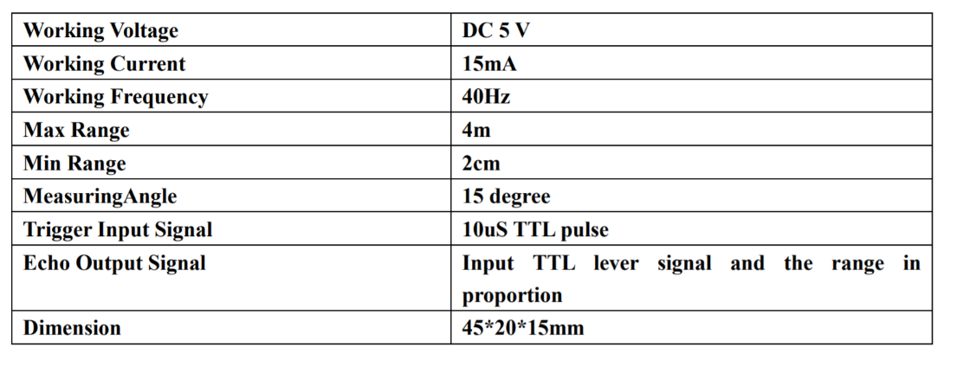

**Working:**

Ultrasonic sensors work by sending out a sound wave at a frequency above the range of human hearing. The transducer of the sensor acts as a microphone to receive and send the ultrasonic sound. Our ultrasonic sensors, like many others, use a single transducer to send a pulse and to receive the echo. The sensor determines the distance to a target by measuring time lapses between the sending and receiving of the ultrasonic pulse.

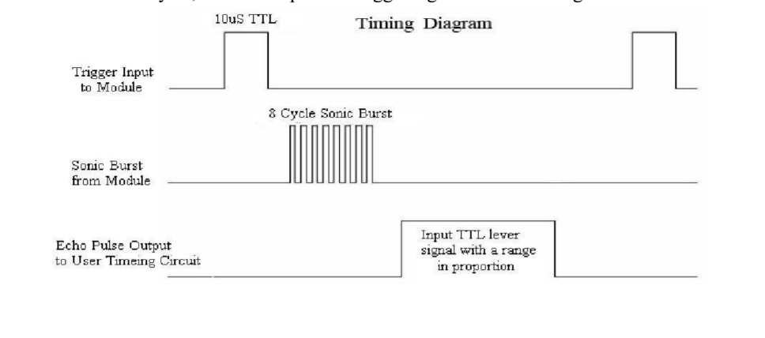

The working principle of this module is simple. It sends an ultrasonic pulse out at 40kHz which travels through the air and if there is an obstacle or object, it will bounce back to the sensor. By calculating the travel time and the speed of sound, the distance can be calculated.

Ultrasonic sensors are a great solution for the detection of clear objects. For liquid level measurement, applications that use infrared sensors, for instance, struggle with this particular use case because of target translucence.

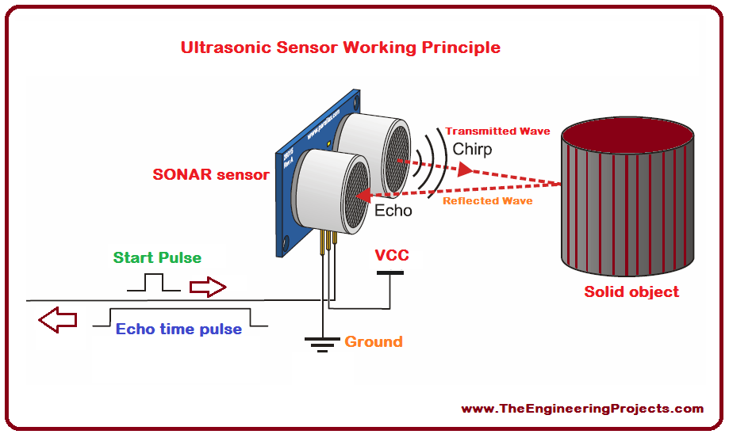

For presence detection, ultrasonic sensors detect objects regardless of the color, surface, or material (unless the material is very soft like wool, as it would absorb sound.)

To detect transparent and other items where optical technologies may fail, ultrasonic sensors are a reliable choice.

* Operating voltage: +5V
* Theoretical Measuring Distance: 2cm to 450cm
* Practical Measuring Distance: 2cm to 80cm
* Accuracy: 3mm
* Measuring angle covered: <15°
* Operating Current: <15mA
* Operating Frequency: 40Hz

**Using Multiple Sensors & Avoiding Disruption:**

When using multiple sensors in an application, it’s important to connect them in a way that will allow you to avoid issues like crosstalk or any other interference.

To prevent the disruption of the ultrasonic signals coming from your sensor, it’s important to keep the face of the ultrasonic transducer clear of any obstructions.

Common obstructions include:

* Dirt
* Snow
* Ice
* Other Condensation

**2.3 Motor Driver:**

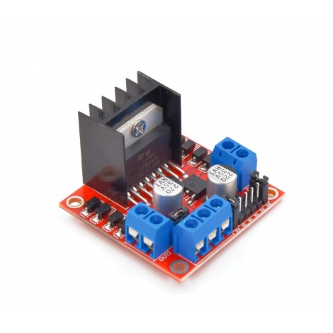Motor drivers acts as an interface between the motors and the control circuits. Motor require high amount of current whereas the controller circuit works on low current signals. So the function of motor drivers is to take a low-current control signal and then turn it into a higher-current signal that can drive a motor.

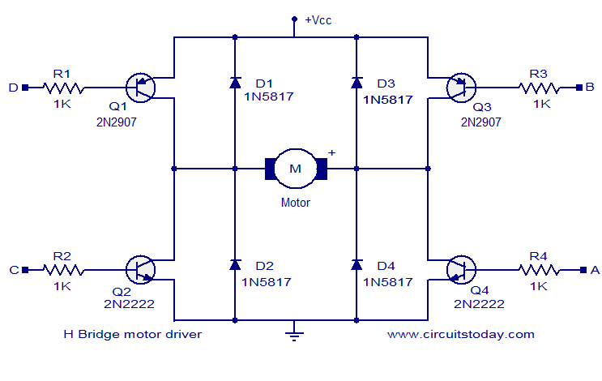

**Different motor drivers for Remote Controlled Robots:**

To control the robot wirelessly through a remote controller we need to interface the motors with the wireless systems such as Bluetooth, 2.4 GHz Rf modules, etc.

Here is the detailed comparision between the suggested motor drivers which will help you to select the combination of motor and motor driver

**2.4 LDR:**

Light dependent resistors, LDRs or photoresistors are often used in electronic circuit designs where it is necessary to detect the presence or the level of light.

These electronic components can be described by a variety of names from light dependent resistor, LDR, photoresistor, or even photo cell, photocell or photoconductor.

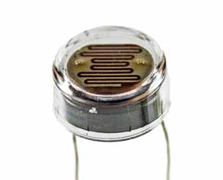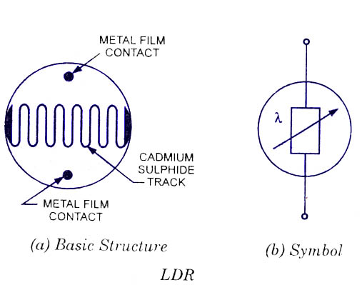

**2.5 Humidity and Temperature Sensor:**

The DHT11 is a basic, ultra low-cost digital temperature and humidity sensor. It uses a capacitive humidity sensor and a thermistor to measure the surrounding air, and spits out a digital signal on the data pin (no analog input pins needed). Its fairly simple to use, but requires careful timing to grab data. You can get new data from it once every 2 seconds, so when using the library from Adafruit, sensor readings can be up to 2 seconds old.

Comes with a 4.7K or 10K resistor, which you will want to use as a pullup from the data pin to VCC.

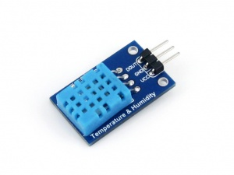

**2.6 Autonomous Robot:**

**2.6.1 Sensors and Devices Required:**

* Devices and Sensors used:
* Arduino UNO
* L298N Dual H Bridge
* SG90 9g Servo
* Sr03 Ultrasonic Sensor
* LDR
* DC Motors
* 9V Batteries
* Rechargeable Battery

**2.7 Circuits:**

Lets the circuits on bread board. Circuit diagrams are shown in each section.

**2.7.1 Ultrasonic sensor along with servo and motor driver:**

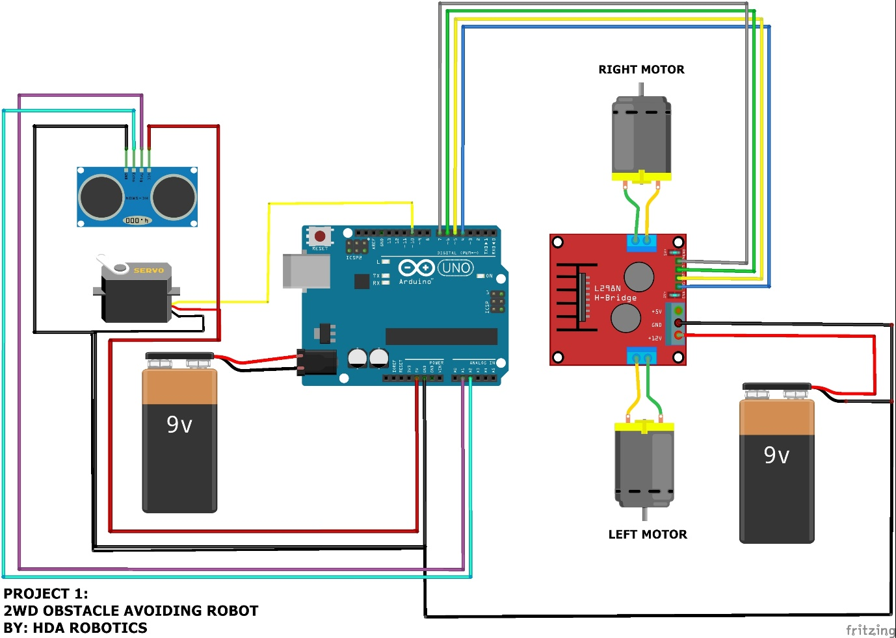

**2.7.2 LDR circuit**

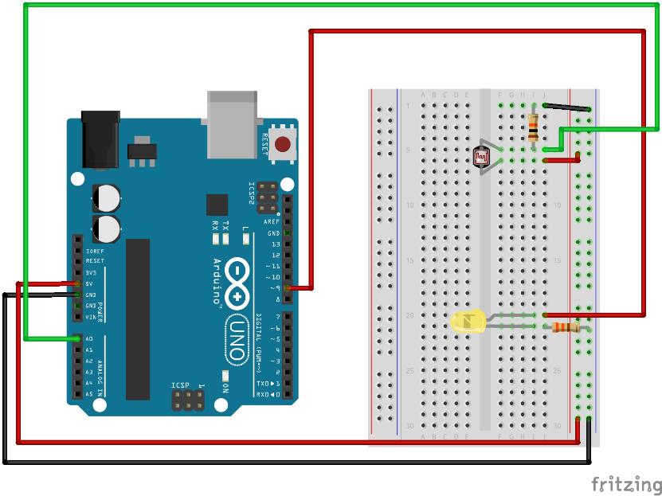

LDR circuit

**2.7.3 DHT11 Circuit:**

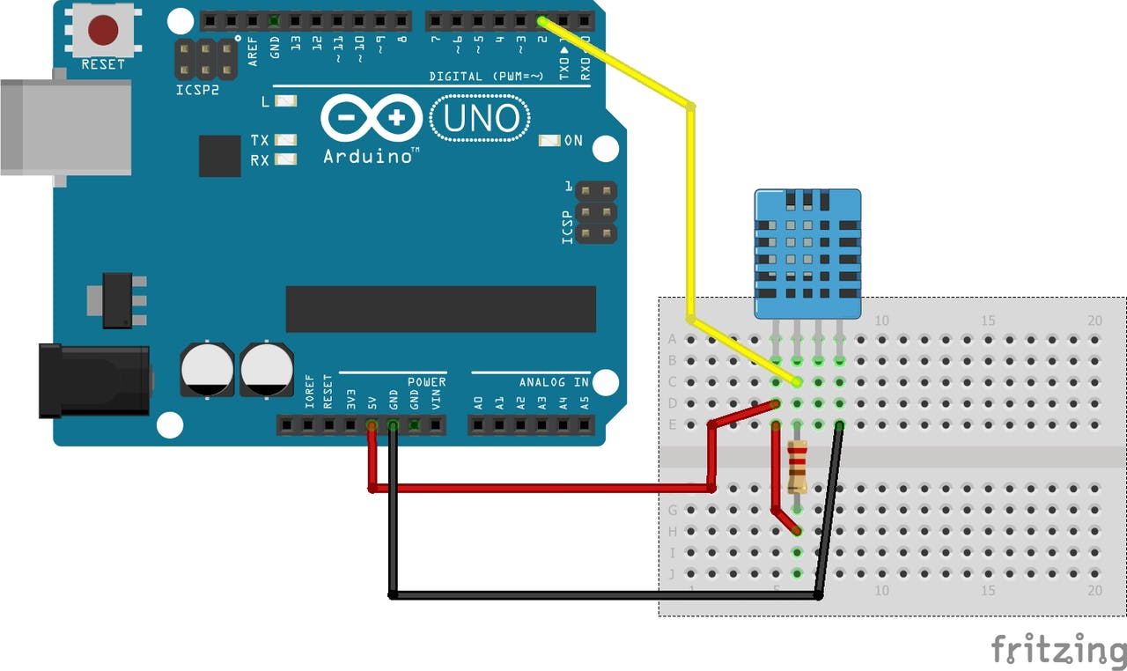

DHT11 Sensor circuit

**2.7.4 LCD with I2C and Arduino circuit:**

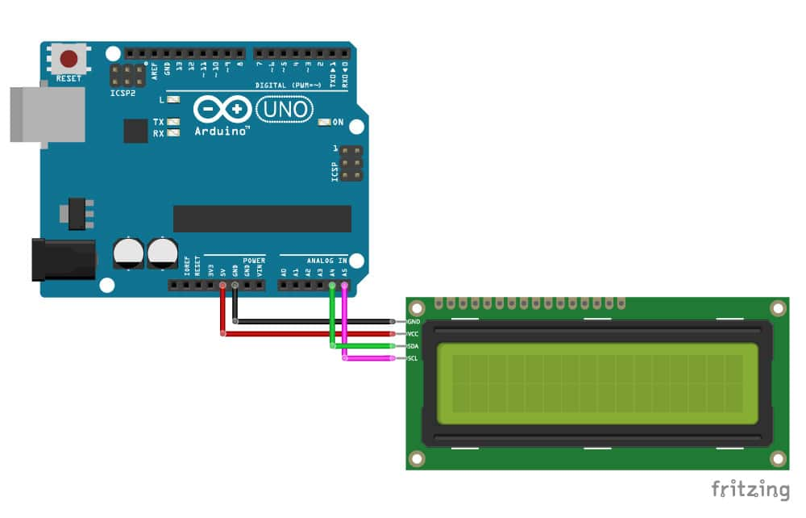

LCD with I2C and Arduino circuit

**2.8 Autonomous Robot Complete Circuit:**

**Chapter 3**

**3.1 Arduino Code:**

**#include <Servo.h>**

**#include <NewPing.h>**

**#include <Wire.h>**

**#include <LiquidCrystal_I2C.h>**

**LiquidCrystal_I2C lcd(0x27, 16, 2);**

**#include <dht.h>**

**#define dht_apin A0**

**dht DHT;**

**const int fanPin = 11;**

**const int ledPin = 12;**

**const int ldrPin = A3;**

**const int LeftMotorForward = 6;**

**const int LeftMotorBackward = 7;**

**const int RightMotorForward = 5;**

**const int RightMotorBackward = 4;**

**#define trig_pin A1**

**#define echo_pin A2**

**#define maximum_distance 200**

**boolean goesForward = false;**

**int distance = 100;**

**NewPing sonar(trig_pin, echo_pin, maximum_distance); //sensor function**

**Servo servo_motor;**

**void setup(){**

**Serial.begin(9600);**

**delay(500);**

**Serial.println("DHT11 Humidity & temperature Sensor\n\n");**

**delay(1000);**

**pinMode(fanPin, OUTPUT);**

**pinMode(dht_apin, INPUT);**

**Serial.begin(9600);**

**pinMode(ledPin, OUTPUT);**

**pinMode(ldrPin, INPUT);**

**pinMode(RightMotorForward, OUTPUT);**

**pinMode(LeftMotorForward, OUTPUT);**

**pinMode(LeftMotorBackward, OUTPUT);**

**pinMode(RightMotorBackward, OUTPUT);**

**servo_motor.attach(9);**

**servo_motor.write(115);**

**delay(2000);**

**distance = readPing();**

**delay(100);**

**distance = readPing();**

**delay(100);**

**distance = readPing();**

**delay(100);**

**distance = readPing();**

**delay(100);**

**lcd.begin();**

**lcd.backlight();**

**lcd.clear();**

**lcd.setCursor(0,0);**

**lcd.print("Autonomus Robot");**

**lcd.setCursor(0,1);**

**lcd.print("CPEN-5(30,24,29)");**

**}**

**void loop(){**

**DHT.read11(dht_apin);**

**if (DHT.temperature > 25) {**

**digitalWrite(fanPin, HIGH);**

**Serial.print("Its HOT, Turn on the FAN : ");**

**Serial.println(DHT.temperature);**

**//delay(1000);**

**}**

**else {**

**digitalWrite(fanPin, LOW);**

**Serial.print("Its COLD, Turn off the FAN : ");**

**Serial.println(DHT.temperature);**

**//delay(1000);**

**}**

**int ldrStatus = analogRead(ldrPin);**

**if (ldrStatus <= 5) {**

**digitalWrite(ledPin, HIGH);**

**Serial.print("Its DARK, Turn on the LED : ");**

**Serial.println(ldrStatus);**

**}**

**else {**

**digitalWrite(ledPin, LOW);**

**Serial.print("Its BRIGHT, Turn off the LED : ");**

**Serial.println(ldrStatus);**

**}**

**int distanceRight = 0;**

**int distanceLeft = 0;**

**delay(50);**

**if (distance <= 20){**

**moveStop();**

**delay(300);**

**moveBackward();**

**delay(400);**

**moveStop();**

**delay(300);**

**distanceRight = lookRight();**

**delay(300);**

**distanceLeft = lookLeft();**

**delay(300);**

**if (distance >= distanceLeft){**

**turnRight();**

**moveStop();**

**}**

**else{**

**turnLeft();**

**moveStop();**

**}**

**}**

**else{**

**moveForward();**

**}**

**distance = readPing();**

**}**

**int lookRight(){**

**servo_motor.write(50);**

**delay(500);**

**int distance = readPing();**

**delay(100);**

**servo_motor.write(115);**

**return distance;**

**}**

**int lookLeft(){**

**servo_motor.write(170);**

**delay(500);**

**int distance = readPing();**

**delay(100);**

**servo_motor.write(115);**

**return distance;**

**delay(100);**

**}**

**int readPing(){**

**delay(70);**

**int cm = sonar.ping_cm();**

**if (cm==0){**

**cm=250;**

**}**

**return cm;**

**}**

**void moveStop(){**

**digitalWrite(RightMotorForward, LOW);**

**digitalWrite(LeftMotorForward, LOW);**

**digitalWrite(RightMotorBackward, LOW);**

**digitalWrite(LeftMotorBackward, LOW);**

**}**

**void moveForward(){**

**if(!goesForward){**

**goesForward=true;**

**digitalWrite(LeftMotorForward, HIGH);**

**digitalWrite(RightMotorForward, HIGH);**

**digitalWrite(LeftMotorBackward, LOW);**

**digitalWrite(RightMotorBackward, LOW);**

**}**

**}**

**void moveBackward(){**

**goesForward=false;**

**digitalWrite(LeftMotorBackward, HIGH);**

**digitalWrite(RightMotorBackward, HIGH);**

**digitalWrite(LeftMotorForward, LOW);**

**digitalWrite(RightMotorForward, LOW);**

**}**

**void turnRight(){**

**digitalWrite(LeftMotorForward, HIGH);**

**digitalWrite(RightMotorBackward, HIGH);**

**digitalWrite(LeftMotorBackward, LOW);**

**digitalWrite(RightMotorForward, LOW);**

**delay(500);**

**digitalWrite(LeftMotorForward, HIGH);**

**digitalWrite(RightMotorForward, HIGH);**

**digitalWrite(LeftMotorBackward, LOW);**

**digitalWrite(RightMotorBackward, LOW);**

**}**

**void turnLeft(){**

**digitalWrite(LeftMotorBackward, HIGH);**

**digitalWrite(RightMotorForward, HIGH);**

**digitalWrite(LeftMotorForward, LOW);**

**digitalWrite(RightMotorBackward, LOW);**

**delay(500);**

**digitalWrite(LeftMotorForward, HIGH);**

**digitalWrite(RightMotorForward, HIGH);**

**digitalWrite(LeftMotorBackward, LOW);**

**digitalWrite(RightMotorBackward, LOW);**

**}**

**3.2 Working of Robot:**

It is an Arduino UNO based project. It’s an Autonomous Robot consist of different sensors to perform different actions.

The car wheels driven by a motor driver which drives DC motors. The main highlight of this robot that it avoid obstacles in its way and changes its path according to the distance from the obstacle. Furthermore it turns on the headlights whenever it enters a dark atmosphere or where the light is dim it turns on the lights.

It has a thermo sensor which detects the temp of the whole system implement on this board and also the atmospheric temperature. If the temperature is more than the defined limit (25°C) then it turns on the fan ported on it until temperature turns below the defined limit (25°C).

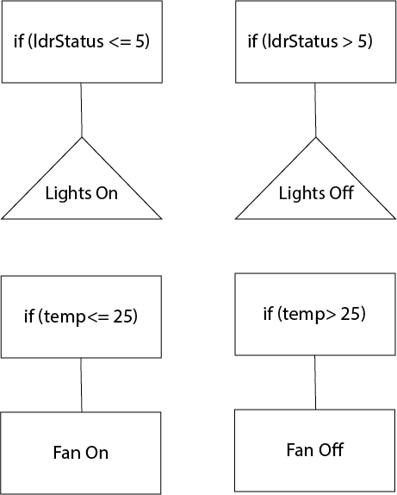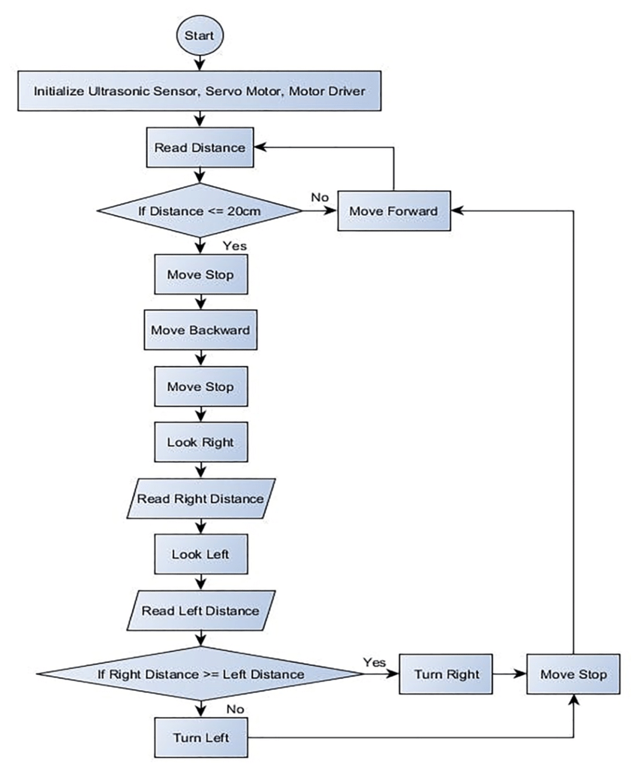

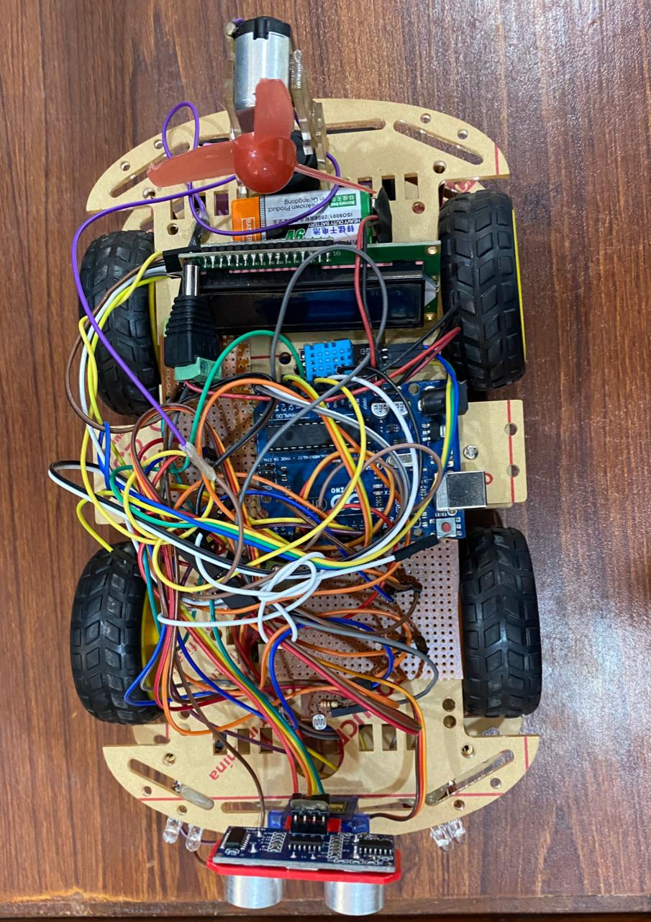

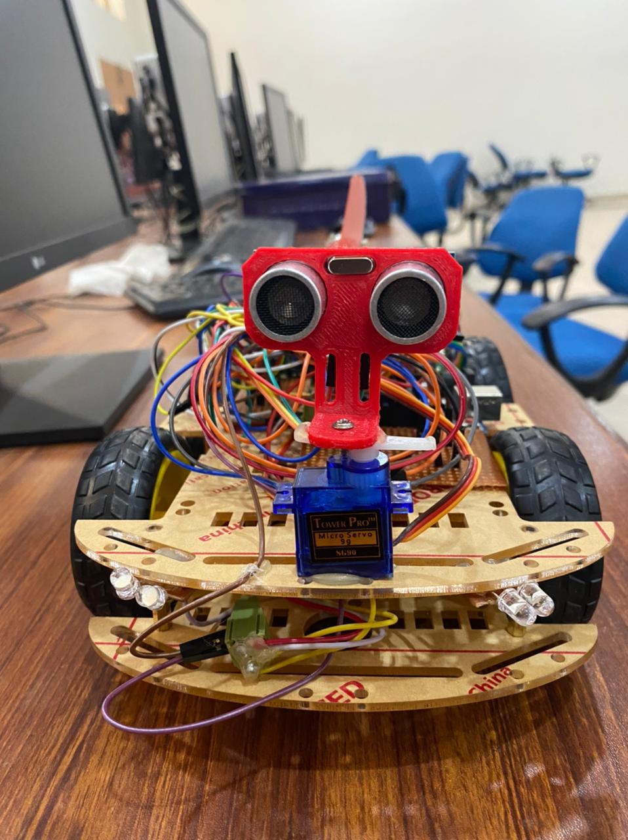

**Chapter 4**

**4.1 Conclusions:**

This project have ability to recognize its path whether it having obstacles in its path or not. It have ability to change its path according to its defined instructions. It choose its way where the distance is greater than the other obstacle on other side.

This robot also have system when it enters in darkmode it turns on lights to make its way proper and help out the driver to drive through dark places like tunnel or in night time.

This robot have a temperature sensor which senses the surroundings temperature and humidity. In this project this is working to sense temperature of board of circuits if it gets higher it turns on the fan to lower its temperature and circuit works fine without any loss.

**4.2 Future Work:**

In addition to this model of autonomous robot many deficiencies left on which can be work in future. Some of them are:

1. Usage of multiple ultrasonic sensors to detect obstacle come from different directions.
2. Fast turn or action to be defined in the project.
3. Usage of lights on complete model to get better lightening in dark areas.
4. Usage of big and 12v fan to overcome heating.

🡨----------------------------🡪